BUDGET REPORT 2024-2025

- Introduction
This paper sets out the principles and details of the budget for the year ending 31st March 2025.

- 2023-2024
The council tax income for the current year is £46.500.

In addition to the day-to-day expenditure the following was included in the current year:

- Repair of wall between St Mary’s Churchyard and the Institute
- Bus stop scheme
- Youth Club
- Community Café pilot scheme

Other projects planned to be completed in the current financial year.
- Toilet refurbishment
- Repairs to St Mary’s churchyard wall
- Lychgate restoration work
- Street furniture restoration
- Telephone box redecoration Watergate Street

- End of year balances
The expected end of year balances is set out below:

FUNDS ESTIMATED AT END OF YEAR 31st March 2024
Income
Balance as of 30th September £99,360
General £3,000
IPCC toilet grant £5,000
Precept £15,500
VAT £3,383
Total income £126,243
Expenditure £20,000
Autumn works programme £7,000
Balance £99,243
Less reserves (for rainy day) £45,000
Youth Club grant aid carried fwd £5,000
Excess reserves £49,243

- Budget 2024-2025
The budget proposed for the ensuing year is set out below with:

- Chart showing various precept increases.
- Increases due to inflation.
- No projects included in these figures at this stage.

A chart showing the approx. council tax cost to a band D household is set out below:

HEADING | CURRENT YEAR | NEXT YEAR NIL  INCREASE | NEXT YEAR 3%  INCREASE | NEXT YEAR 5%  INCREASE | NEXT YEAR 7.5% INCREASE | NEXT YEAR  10%  INCREASE
Precept | £46,500 | £46,500 | £48,000 | £49,000 | £50,000 | £51,000
PER YEAR | £54.73 | £54.73 | £56.49 | £57.67 | £58.85 | £60.02
PER MONTH | £4.56 | £4.56 | £4.70 | £4.80 | £4.90 | £5.00
PER WEEK | £1.05 | £1.05 | £1.08 | £1.11 | £1.13 | £1.15
PER  DAY | £0.149 | £0.149 | £0.155 | £0.158 | £0.161 | £0.164

- What is included?
The budget includes allowances for:

- General delivery of services including an allowance for annual repairs and maintenance.
- Continued provision of the youth club.
- No increase in existing staff salaries.
- No allowance for the school crossing

No projects have been included in these figures.

- Suggested allowance for projects:
The suggested projects for 2024-2025 are:

- Christmas Lights
- Fitness trail
- Repair of Deri Woods car park and path in St Mary’s churchyard
- Improvements to signage

Total budget for the above total £10,000.

Funding for these projects to come from:

- Repairs budget
- Reserves
- Grant aid

- Policy on budget and reserves
The Council has larger than usual reserves which are calculated to be £102,000 at end of year 31st March 2024.

The Council is advised to retain a level of reserves at £45,0000 as a ‘rainy day and unforeseen expenditure’. Any monies spent from this reserve should be replace asap.

Currently the excess reserves total some £49,000 which can be spent on
projects which are a ‘one off’ and not a continual liability over future
years.

The excess reserves should not be used for day to day expenditure.
The Audit has identified that the reserves are high and that this should
be considered when setting the precept.

To this end the following reserves policy is recommended:

‘The level of reserves at £45,000 is to be retained for security.
The council will seek to complete projects which benefit the
community over the next three years from the excess reserves. However the precept is to be set to cover the council’s normal running costs.’

5. Charts
Charts showing the various elements of the budget are attached.

- Chart showing income sources – appendix 1
- Chart showing costs in each sector – appendix 2
- Chart showing the approx split of the council tax bill – appendix 3
- Budget in summary – appendix 4
- Budget service by service – appendix 5

- Decision
The council needs to consider:

Any increase to the Council Tax for the ensuring.
The budget as set out in this report.
The reserves policyas set out in this report.
The council should consider any increase in staff costs before setting
the budget so that the figures are accurate for the year.

Robert Robinson
Town Clerk October 2023

APPENDIX 1

INCOME SOURCES – CURRENT YEAR AND BUDGET 2024-2025
PRECEPTT

PRECEPT

APPENDIX 2

EXPENDITURE SERVICE BY SERVICE
CURRENT YEAR AND BUDGET 2024-2025
PROJECTS

APPENDIX 3

CHART SHOWING ALLOCATION OF COUNIL TAX

APPENDIX 4

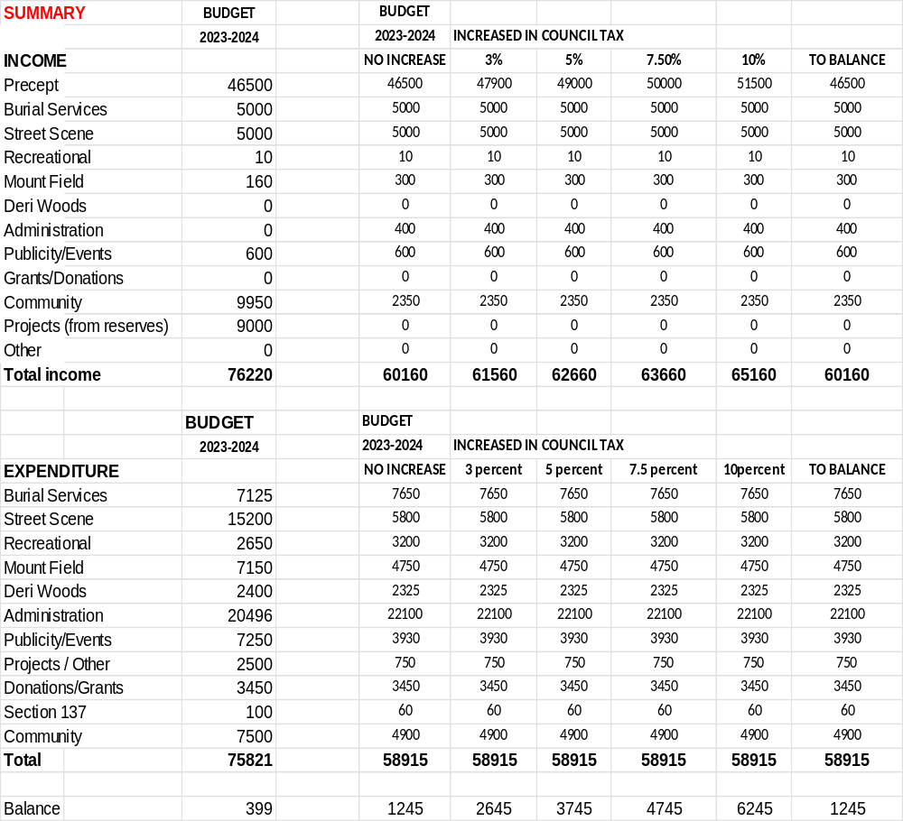

APPENDIX 5

